Unit 4 Assignment 1: Reshaping Data
Shubham Raj
IN404 Machine Learning
Purdue University Global

Item 1: Python Program Execution
I completed all of the "YOUR CODE HERE" sections in the provided IN404_Unit4.py starter file. The program parses the IN404_Reviews.csv data set, performs sentiment analysis on app reviews, and compares accuracy scores across multiple CountVectorizer and TF-IDF configurations using logistic regression.
The completed Python file (IN404_Unit4.py) is submitted alongside this document. Below are the screenshots of the program execution output:
Figure 1: Program Output (Part 1)
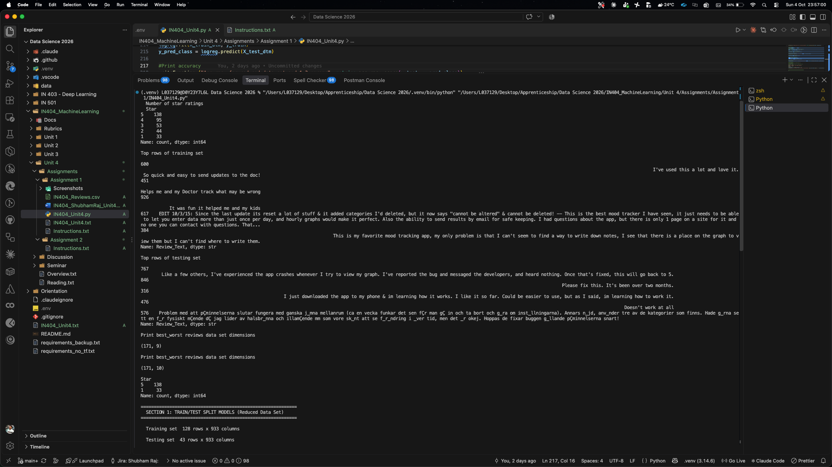

Figure 2: Program Output (Part 2)
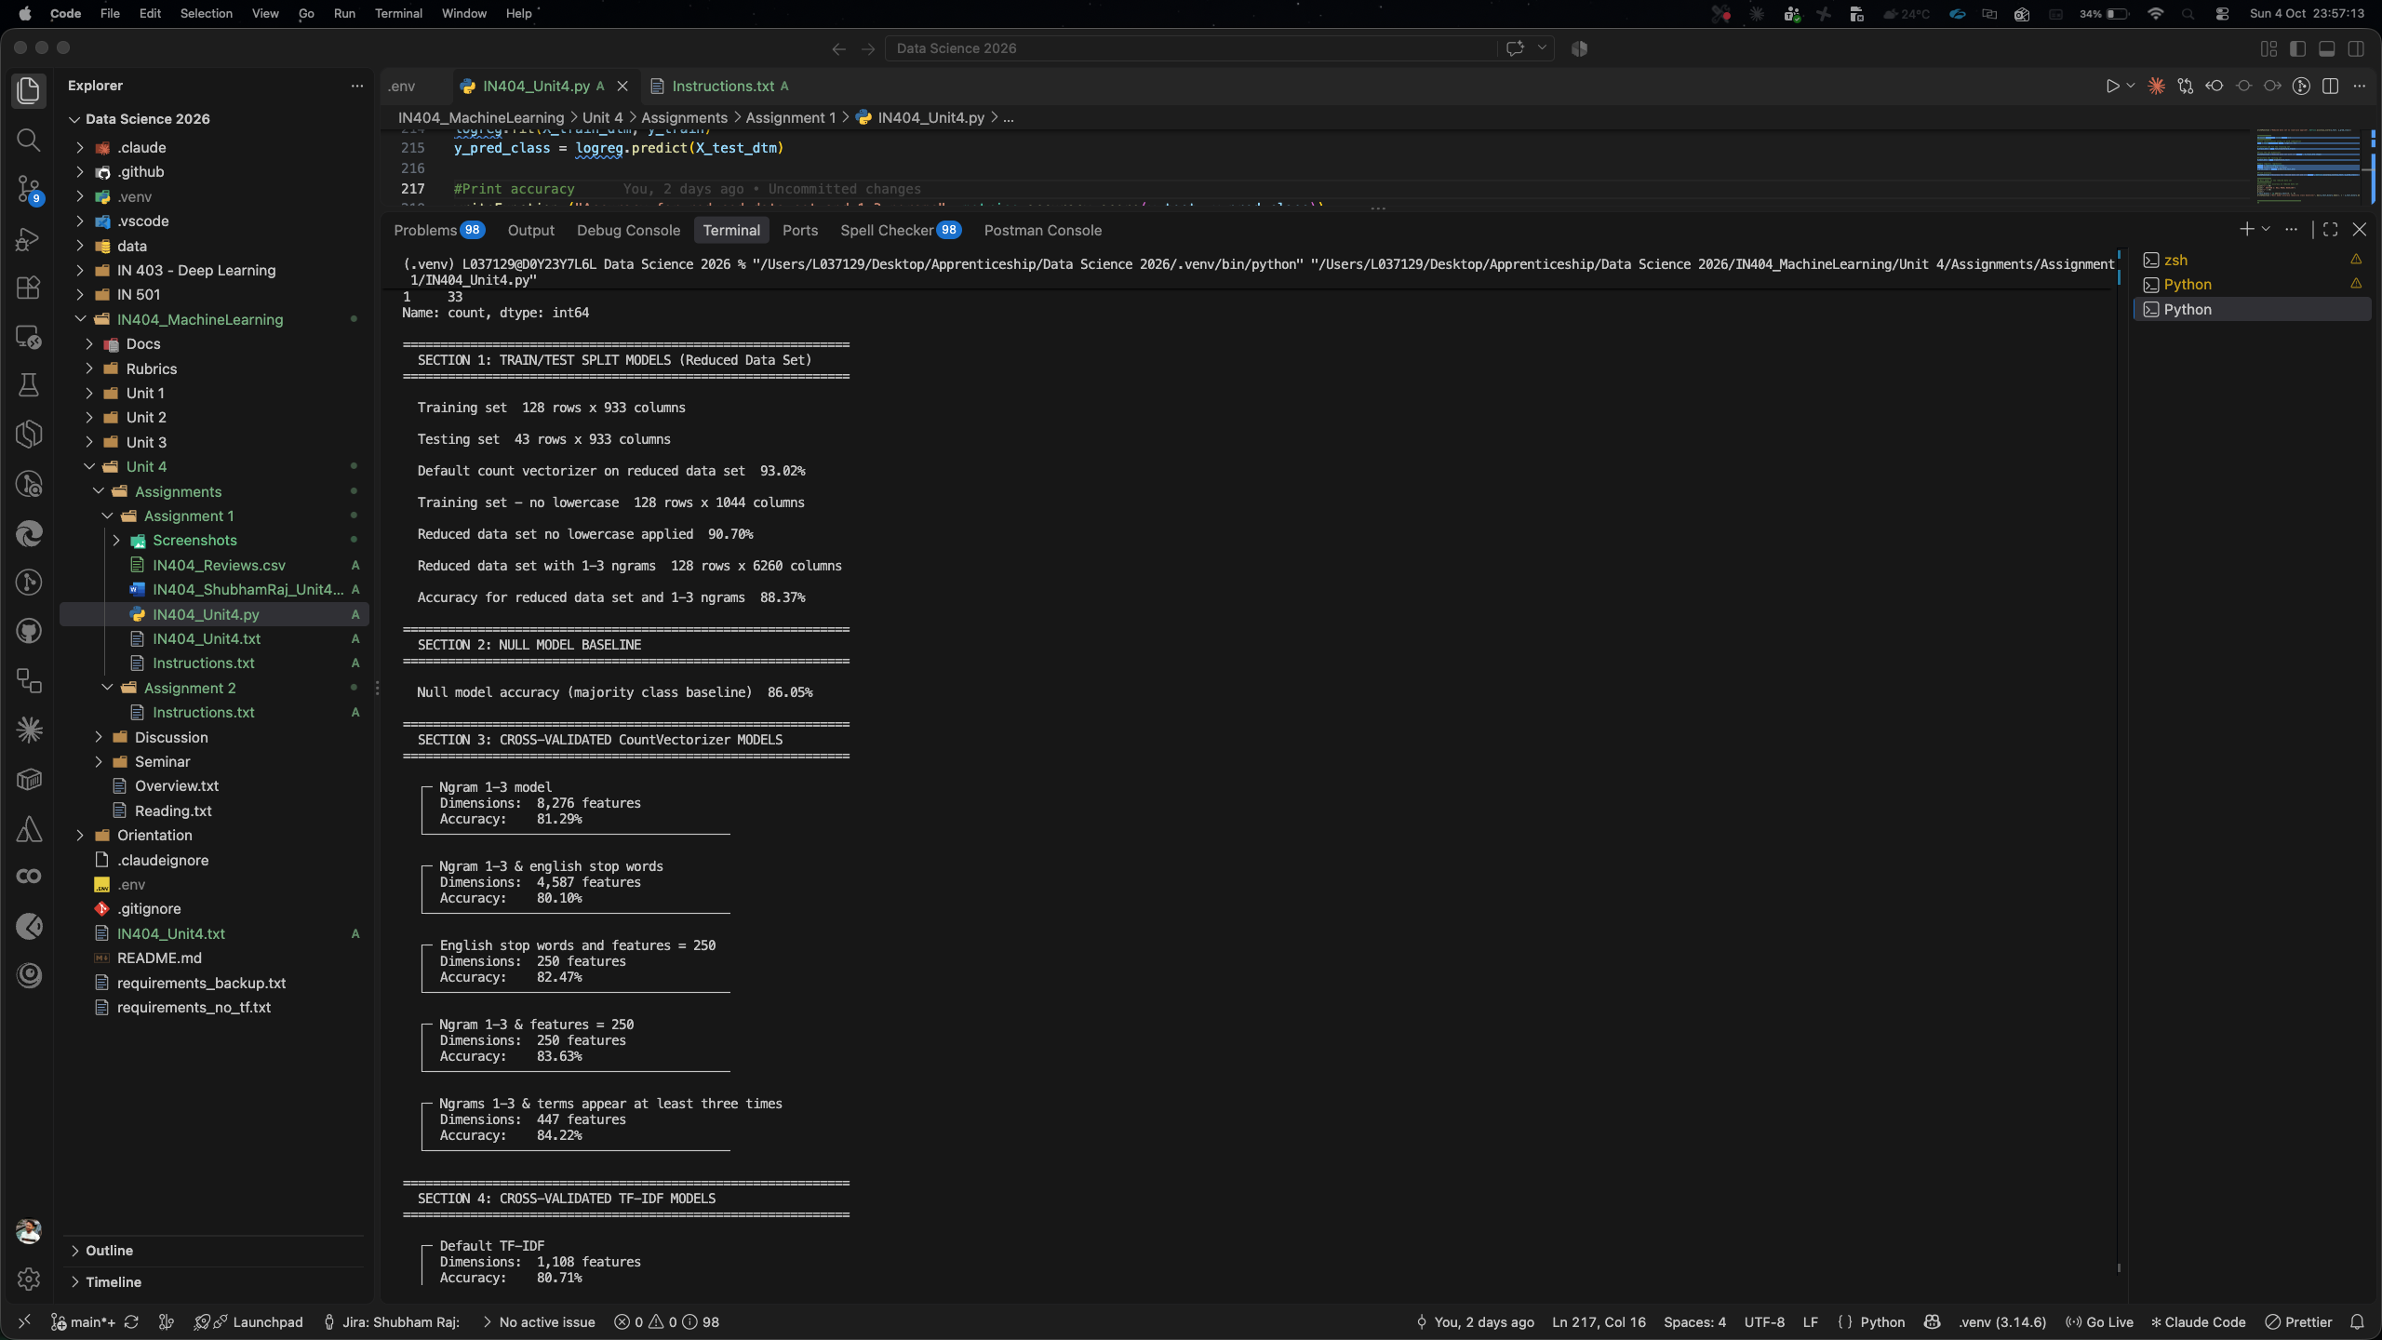

Figure 3: Program Output (Part 3)
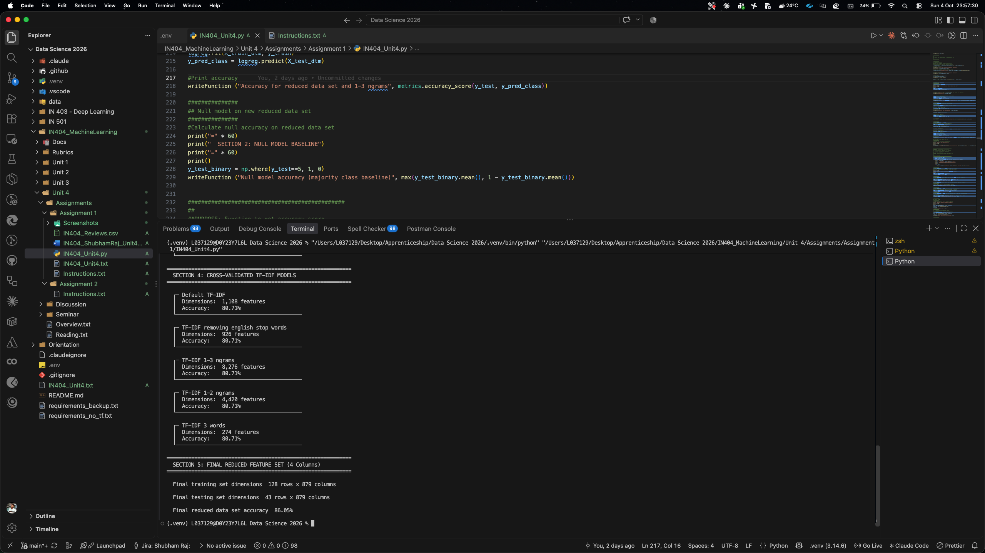

Item 2: All 15 Accuracy Scores
The following table lists all 15 accuracy scores produced by the program:
# | Model | Evaluation Method | Accuracy
1 | Default CountVectorizer | Train/Test Split | 93.02%
2 | CountVectorizer (no lowercase) | Train/Test Split | 90.70%
3 | CountVectorizer (ngram 1–3) | Train/Test Split | 88.37%
4 | Null Model (majority class) | Baseline | 86.05%
5 | CountVectorizer ngram 1–3 | 5-Fold Cross-Validation | 81.29%
6 | CV ngram 1–3 + stop words | 5-Fold Cross-Validation | 80.10%
7 | CV stop words + 250 features | 5-Fold Cross-Validation | 82.47%
8 | CV ngram 1–3 + 250 features | 5-Fold Cross-Validation | 83.63%
9 | CV ngram 1–3 + min_df=3 | 5-Fold Cross-Validation | 84.22%
10 | Default TF-IDF | 5-Fold Cross-Validation | 80.71%
11 | TF-IDF + stop words removed | 5-Fold Cross-Validation | 80.71%
12 | TF-IDF ngram 1–3 | 5-Fold Cross-Validation | 80.71%
13 | TF-IDF ngram 1–2 | 5-Fold Cross-Validation | 80.71%
14 | TF-IDF min_df=3 | 5-Fold Cross-Validation | 80.71%
15 | Final Reduced Feature Set (4 columns) | Train/Test Split | 86.05%

Item 3: Accuracy Scores vs. the Null Model
The null model accuracy is 86.05%, which represents the accuracy achieved by simply predicting the majority class (5-star reviews) every time. Any useful model must beat this baseline to demonstrate that it has actually learned meaningful patterns from the data.

Models That Beat the Null Model
Three models exceeded the null model accuracy, and all three used the train/test split method:
- Default CountVectorizer — 93.02%
- CountVectorizer with no lowercase — 90.70%
- CountVectorizer with ngram 1–3 — 88.37%
None of the 5-fold cross-validated models (items 5–14) beat the null model. Their accuracy scores ranged from 80.10% to 84.22%, all falling below the 86.05% baseline. The final reduced feature set model (item 15) tied the null model exactly at 86.05%.

Which Was the Best Model?
The Default CountVectorizer using a train/test split was the best model with an accuracy of 93.02%. It beat the null model by approximately 7 percentage points.

Which Two Tied as the Second Best Model?
The Null Model and the Final Reduced Feature Set model both tied at exactly 86.05% accuracy. This is a notable result because it means the reduced 4-column feature set model (which used Review_Text, Review_Title, sentiment, and sentiment_title) performed no better than simply guessing the majority class.

What Do These Results Tell Me?
These results tell me several important things. First, the train/test split method produces optimistically high accuracy scores compared to cross-validation. The same CountVectorizer ngram 1–3 configuration scored 88.37% with a single train/test split but only 81.29% with 5-fold cross-validation. This shows that a single split can overfit to the particular test set chosen.
Second, the class imbalance in this data set (138 five-star reviews vs. only 33 one-star reviews) makes the null model quite strong at 86.05%. A model that only predicts the majority class already performs well, which makes it challenging for ML models evaluated with cross-validation to outperform it.
Third, more complex feature engineering does not always lead to better accuracy. The default CountVectorizer outperformed configurations with ngrams, stop-word removal, and feature limits. Simpler representations sometimes generalize better on small data sets.

Item 4: Comparing Ngram 1–3 vs. Ngram 1–2
I ran both tokenization models through the testVector function using 5-fold cross-validation:
vect = CountVectorizer(ngram_range=(1, 3))
testVector("Ngram 1-3 model", vect)
# Dimensions: 8,276 features | Accuracy: 81.29%
vect = CountVectorizer(ngram_range=(1, 2))
testVector("Ngram 1-2 model", vect)
# Dimensions: 4,420 features | Accuracy: 81.87%

Which Model Had the Better Accuracy Score?
The ngram 1–2 model had a slightly better accuracy score at 81.87% compared to the ngram 1–3 model at 81.29%, a difference of about 0.58 percentage points.

Why Do I Think They Scored Differently?
I believe the ngram 1–2 model scored better because of the curse of dimensionality on a small data set. The ngram 1–3 model generates 8,276 features — nearly double the 4,420 features of the ngram 1–2 model. Those additional 3-word combinations (trigrams) create many highly sparse features that appear in very few reviews. With only 171 reviews in the reduced data set, the model does not have enough training examples to learn meaningful patterns from those rare trigram features. Instead, the extra features introduce noise, which slightly degrades the model’s ability to generalize. The ngram 1–2 model avoids this overfitting by using a smaller, more manageable feature space where each feature is more likely to appear across multiple documents.

Item 5: Train/Test Split vs. 5-Fold Cross-Validation
The code in Item 1 uses two distinct evaluation strategies. I will compare how each was implemented and which I would expect better results from.

Train/Test Split
The train/test split divides the data into two parts once. The code performs this as follows:
X_train, X_test, y_train, y_test = train_test_split(X, y, random_state=2)
vect = CountVectorizer()
X_train_dtm = vect.fit_transform(X_train)
X_test_dtm = vect.transform(X_test)
logreg = LogisticRegression()
logreg.fit(X_train_dtm, y_train)
y_pred_class = logreg.predict(X_test_dtm)
metrics.accuracy_score(y_test, y_pred_class)
By default, train_test_split uses a 75/25 ratio, so 75% of the data trains the model and the remaining 25% is used to test it. The model is trained once and evaluated once. The random_state=2 parameter ensures the same split is produced every time the code runs for reproducibility.

5-Fold Cross-Validation (testVector Function)
The testVector function uses 5-fold cross-validation through cross_val_score:
def testVector(message, vect):
logreg = LogisticRegression()
X_dtm = vect.fit_transform(X)
cross_val_score(logreg, X_dtm, y, cv=5, scoring='accuracy').mean()
With cv=5, the data is divided into 5 equal folds. The model trains on 4 folds and tests on the remaining 1, repeating this process 5 times so that every fold serves as the test set once. The final accuracy is the mean of all 5 accuracy scores.

Which Would I Expect Better Results From?
I would expect the train/test split to produce higher accuracy numbers, but I would trust the 5-fold cross-validation results more as a realistic estimate of model performance. My results confirm this: the default CountVectorizer scored 93.02% with train/test split but only around 81–82% with cross-validation.
The train/test split can produce optimistically high or low scores because it depends entirely on which data points happen to land in the test set. A single lucky split can overestimate accuracy. Cross-validation is more reliable because it averages over 5 different splits, reducing the variance in the accuracy estimate. Every data point is used for both training and testing, making it a more thorough and robust evaluation. In practice, I would use cross-validation to select the best model and only use a final hold-out test set for reporting the chosen model’s performance.

Item 6: CountVectorizer Parameters
I researched the following CountVectorizer flags used in the code:

ngram_range
The ngram_range parameter specifies the range of n-grams to extract from the text. It takes a tuple (min_n, max_n). For example, ngram_range=(1, 3) extracts unigrams (single words), bigrams (two-word phrases), and trigrams (three-word phrases). The default is (1, 1), which uses only individual words. Including higher-order n-grams captures phrase-level context (e.g., "not good" as a bigram conveys different meaning than "not" and "good" separately) but dramatically increases the feature space.

stop_words
The stop_words parameter filters out common words that carry little semantic meaning. Setting stop_words='english' removes a built-in list of English stop words such as "the," "is," "and," "in," and similar high-frequency words. This reduces the feature space and can improve model performance by eliminating noise. A custom list of stop words can also be provided.

max_df
The max_df parameter sets the maximum document frequency threshold. Terms that appear in more than this proportion of documents are ignored. For example, max_df=0.8 would exclude any word appearing in more than 80% of documents. This is useful for removing domain-specific stop words that appear too frequently to be discriminative. It can also accept an integer, in which case it represents the absolute number of documents rather than a proportion.

min_df
The min_df parameter sets the minimum document frequency threshold. Terms that appear in fewer documents than this value are excluded. For example, min_df=3 means a word must appear in at least 3 documents to be included as a feature. This helps remove very rare terms that are unlikely to generalize — such as misspellings or highly specific references — reducing noise and the dimensionality of the feature matrix.

max_features
The max_features parameter limits the total number of features (vocabulary size) to the top N most frequent terms. For example, max_features=250 keeps only the 250 most common terms across all documents. This provides a simple way to control dimensionality and can prevent overfitting by focusing the model on the most frequently occurring and presumably most informative features.

Item 7: Count Vectorization vs. TF-IDF

What Is Count Vectorization?
Count Vectorization (CountVectorizer) converts text documents into a matrix of token counts. Each document becomes a row, and each unique word (or n-gram) becomes a column. The cell values represent how many times each token appears in each document. It treats every word occurrence equally — a word appearing 5 times gets a count of 5 regardless of how common it is across the corpus.

What Is TF-IDF?
Term Frequency–Inverse Document Frequency (TfidfVectorizer) also converts text into a numerical matrix, but it applies a weighting scheme. The term frequency (TF) component measures how often a word appears in a single document, while the inverse document frequency (IDF) component penalizes words that appear across many documents. The result is that words unique to a few documents receive higher weights, while common words that appear everywhere receive lower weights.

When Would I Use Each?
I would use Count Vectorization when working with smaller data sets where simple word counts are sufficient, or when the downstream model can handle raw frequency information well (e.g., Naive Bayes classifiers, which naturally work with count data). It is also a good baseline approach.
I would use TF-IDF when working with larger corpora where common words could dominate the feature space. TF-IDF is particularly useful for information retrieval, document similarity, and tasks where the uniqueness of words matters more than their raw frequency. It works well when some documents contain highly repetitive common terms that would otherwise overwhelm the signal.

Which Gave the Better Accuracy Results?
In my results, Count Vectorization gave better accuracy across all comparable configurations:
Configuration | CountVectorizer | TF-IDF
Default | 81.29% | 80.71%
Stop words removed | 80.10% | 80.71%
Ngram 1–3 | 81.29% | 80.71%

The best cross-validated CountVectorizer model (ngram 1–3, min_df=3) achieved 84.22%, while all TF-IDF variations were essentially flat at 80.71%.

Why?
I believe Count Vectorization outperformed TF-IDF on this data set for two reasons. First, the data set is small (171 reviews after filtering to 1-star and 5-star). TF-IDF’s IDF weighting is most beneficial with larger corpora where term frequency distributions are more stable and meaningful. With a small corpus, the IDF weights can be noisy and may suppress useful terms that happen to appear in several of the few documents.
Second, for binary sentiment classification (1-star vs. 5-star), the simple presence and frequency of sentiment-bearing words like “love,” “great,” “terrible,” or “awful” is often more important than their relative rarity across documents. CountVectorizer preserves these raw counts, allowing the logistic regression model to directly learn from word frequency patterns. TF-IDF’s reweighting may actually dilute the signal from common but strongly sentiment-bearing words, which is why all five TF-IDF configurations produced nearly identical accuracy scores — the IDF weighting essentially flattened the differences between configurations.

References
Scikit-learn. (n.d.). sklearn.feature_extraction.text.CountVectorizer. https://scikit-learn.org/stable/modules/generated/sklearn.feature_extraction.text.CountVectorizer.html
Scikit-learn. (n.d.). sklearn.feature_extraction.text.TfidfVectorizer. https://scikit-learn.org/stable/modules/generated/sklearn.feature_extraction.text.TfidfVectorizer.html
Scikit-learn. (n.d.). sklearn.model_selection.cross_val_score. https://scikit-learn.org/stable/modules/generated/sklearn.model_selection.cross_val_score.html

